Sean Gordon

CprE 431

Module 2 Lab

(a) Using Cygwin command prompt, enter the following command: 

The hash key (D6192FC25D86EEECB9B4E8A54DA0FDD2) can then be used to open the zip file.

(b) The last (most secure and more commonly used) algorithm was the correct one, outputting a text file with the secret message decoded inside.

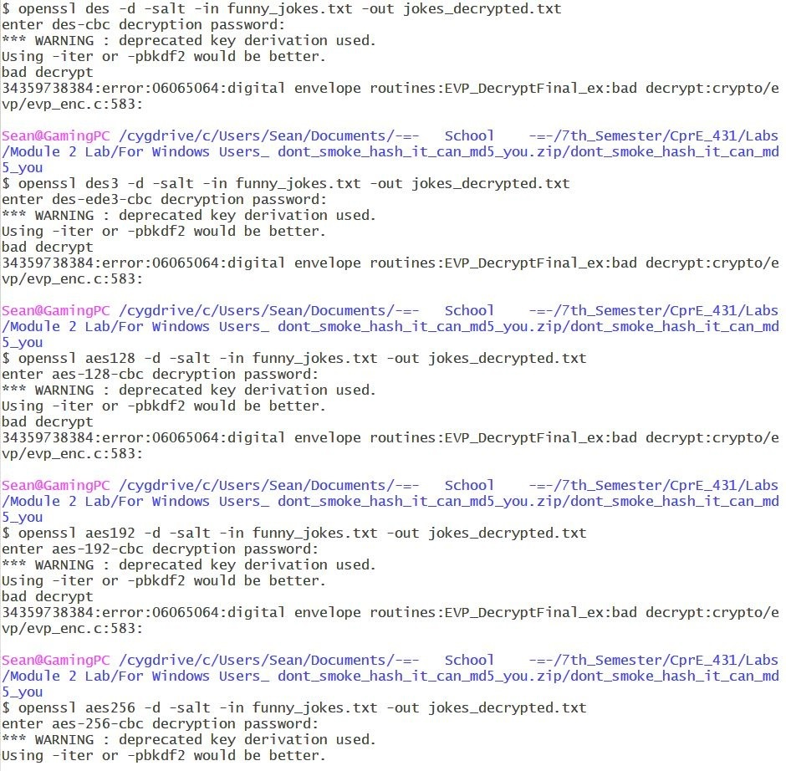

(c) Using the instructions found within the decoded message, I went to [www.spammimic.com](http://www.spammimic.com) and used their spreadsheet decoder to find the message hidden within the excel file.

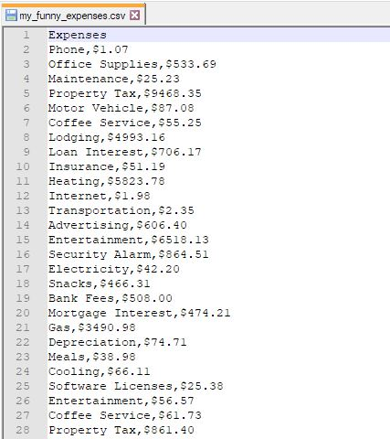 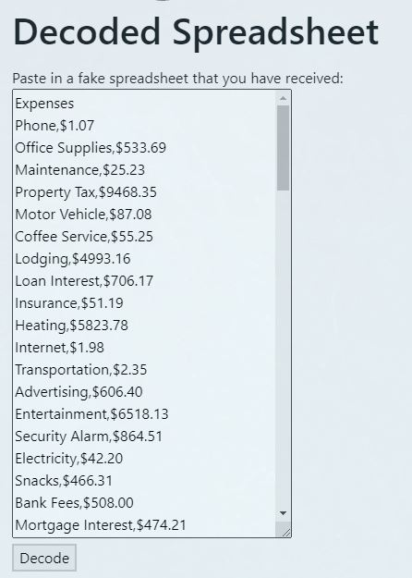

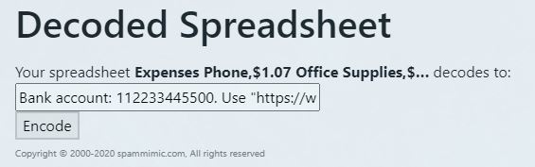

(d) Using the instructions decoded from the excel file, I went to <https://www.mobilefish.com/services/steganography/steganography.php> and inserted the attached photograph and, with the bank account number as the password, decoded the image.

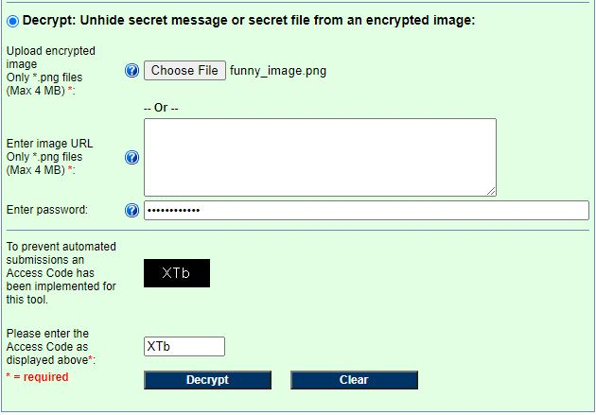

P.S. If I paid a guy to covertly leak iPhone design files and that jpeg is what I got in return, I think I would break cover and stab him lol.